
A
Practical Assignment
On
Python Programming Lab Records
Master of Computer Application -I Sem

RUNGTA INTERNATIONAL SKILLS UNIVERSITY

SESSION: 2025-26

Submitted To:-  Miss Kavita Kanwar | Submitted By:-  Shashank Sinha  ERP :- RU-25-11337

RUNGTA INTERNATIONAL SKILLS UNIVERSITY,CG
SCHOOL OF INFORMATION TECHNOLOGY

INDEX
S.No | Name of Practical | Submission Date | Remarks
 | Write a program to check whether the year is leap or not
 | Write a program to count no. of vowels in a string.
 | Write a program to reverse a number.
 | Write a program to find mean, median and mode of given number.
 | Write a Python program to reverse only the vowels in a given string, keeping other characters in their original positions.
 | Create a script that takes an integer and displays its binary, octal and hexadecimal representations neatly formatted.
 | Given a list of items (possible with duplicates), write a program that removes duplicates and displays that sorted list.
 | Accept a list of students and their marks as tuples. Display the name of the student with the highest marks.
 | Read data from a CSV file containing employee details (name, department, salary) and display the average salary by department.
Write a python program using math module to calculate:

- Square root of a number
- Factorial of a number
- Power of a number
( take input from the user )
 | Write a python program to find the area and circumference of a circle using math module, take input from the user.
 | Create a list of student and select CR randomly, then shuffle the list and print it.
 | Write a python program to generate a random password of 12 characters using UPPERCASE, lowercase, digits and special symbols(!, @, #, $, *). Password should start with Capital letter or digits.
 | Create a package named shapes that contains two modules: circle.py and rectangle.py. Each module should compute area and perimeter of the shape. Write the complete directory structure and sample code.
Write a program that asks the user for an index and prints the element at that index from a predefined list. Handle:

- IndexError (index out of range)
- TypeError (if user enters a non-integer index)
- Print the specific exception message using except Exception as e.
 | Implement a supervised learning model to classify flowers in the Iris dataset using decision tree classifier. Print the accuracy of the model.
 | Use Support Vector Machine (SVM) on the breast cancer datasets to classify malignant vs benign tumors.
 | Perform Principal Component Analysis (PCA) on the digits dataset and reduce the dimension to 2. Print the explained variance ratio.
 | Apply K-Means clustering on the Iris Dataset and print cluster label
 | Write a Python program to perform basic EDA on a student performance dataset to understand its structure and summary statistics.
 | Write a Python program using pandas to analyze a sales dataset and extract meaningful insights.
 | Write a Python program to visualize an employee dataset using matplotlib and seaborn to understand data distribution and relationships.

Practical-1
Aim: Write a program to check whether the year is leap or not
Code :-

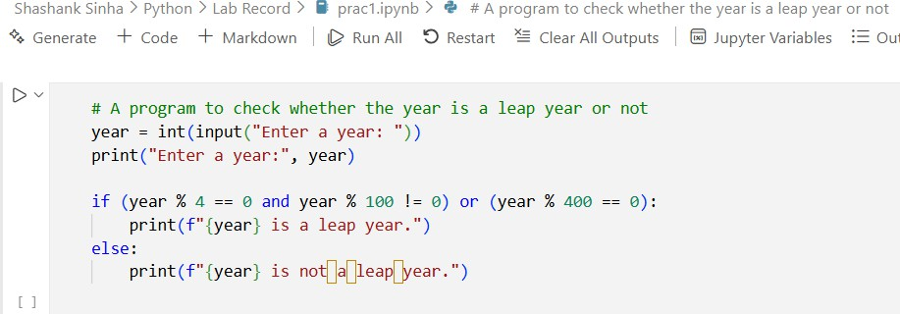
Output :-
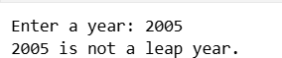

Practical-2

Aim: Write a program to count no. of vowels in a string.
Code :-

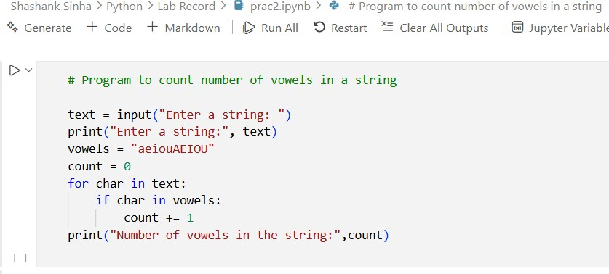

Output :-
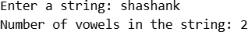

Practical-3
Aim: Write a program to reverse a number.
Code :-
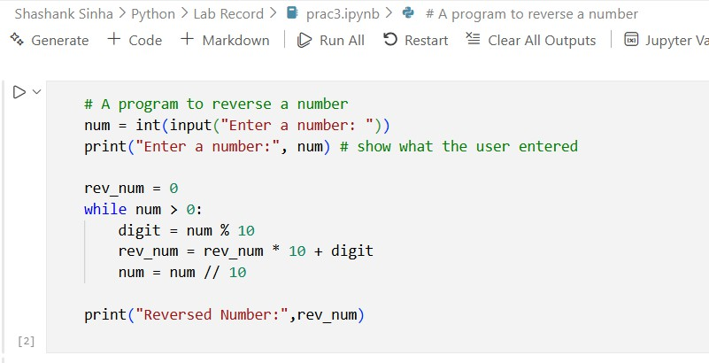

Output :-
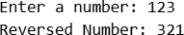

Practical-4
Aim: Write a program to find mean, median and mode of given number.
Code :-
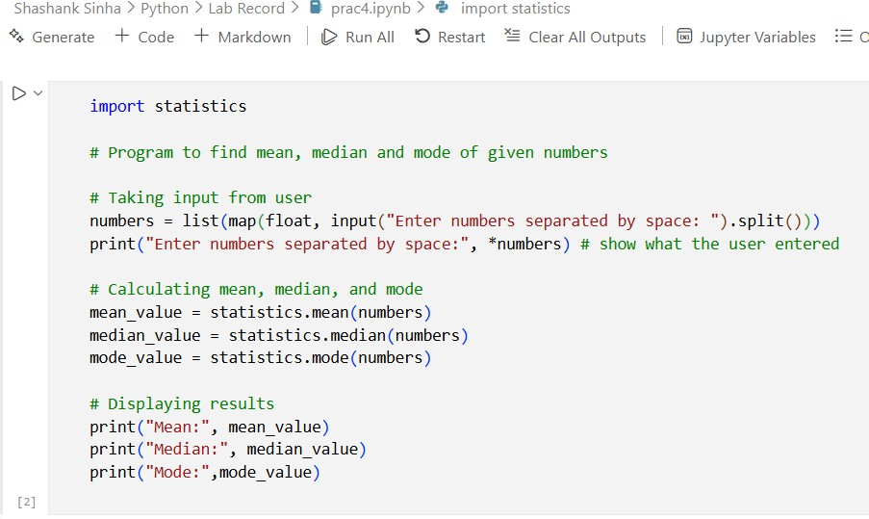

Output :-
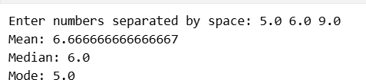

Practical-5
Aim: Write a Python program to reverse only the vowels in a given string, keeping other characters in their original positions.
Code :-
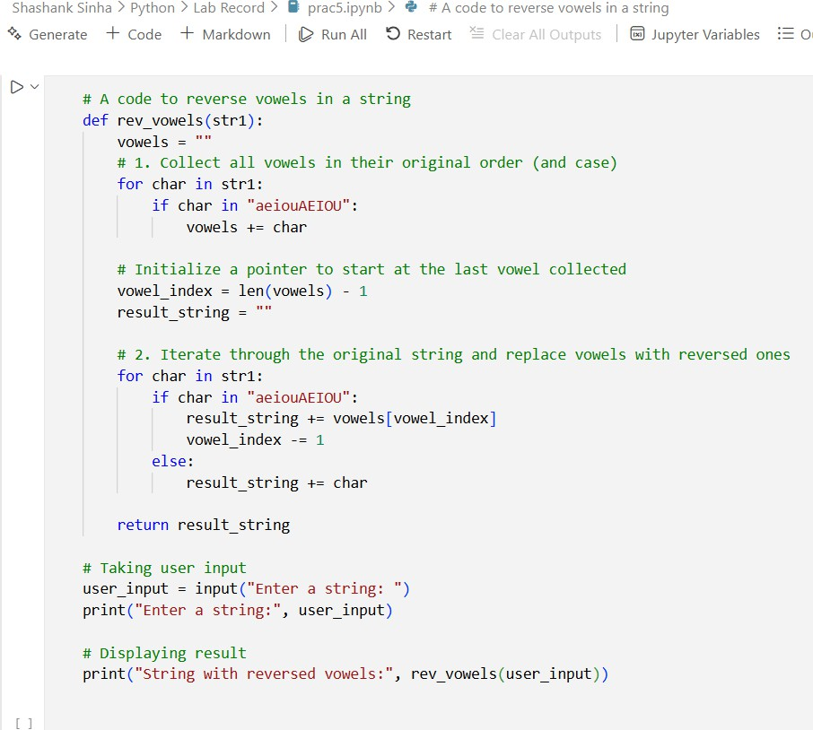

Output :-
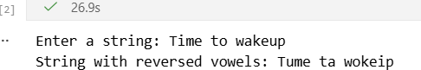

Practical-6
Aim: Create a script that takes an integer and displays its binary, octal and hexadecimal representations neatly formatted.
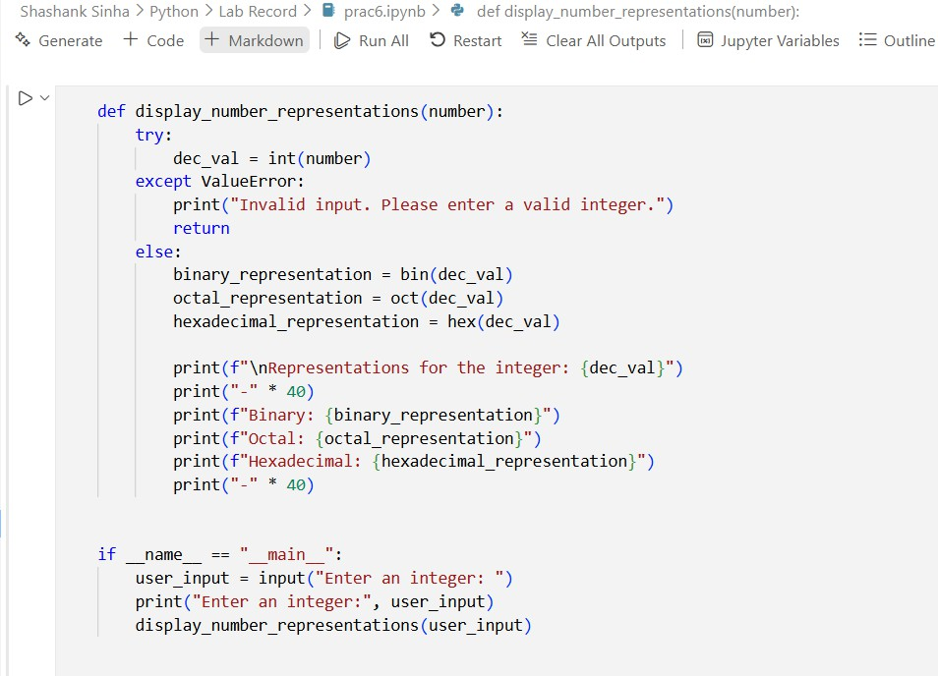
Code :-

Output :-
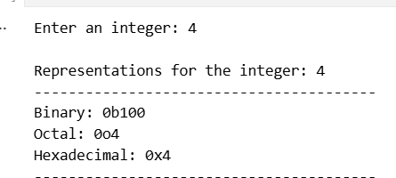

Practical-7

Aim: Given a list of items (possibly with duplicates), write a program that removes duplicates and displays that sorted list.
Code :-
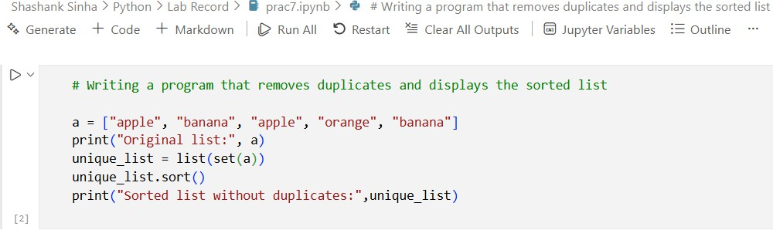

Output :-

Practical-8
Aim: Accept a list of students and their marks as tuples. Display the name of the student with the highest marks.
Code :-
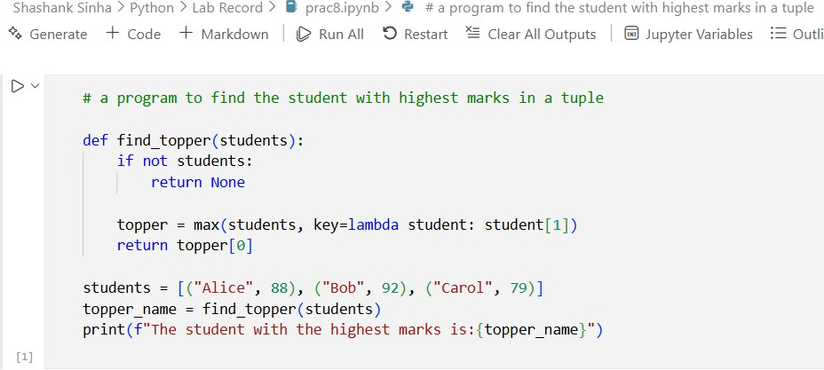

Output :-

Practical-9
Aim: Read data from a CSV file containing employee details (name, department, salary) and display the average salary by department.
Code :-
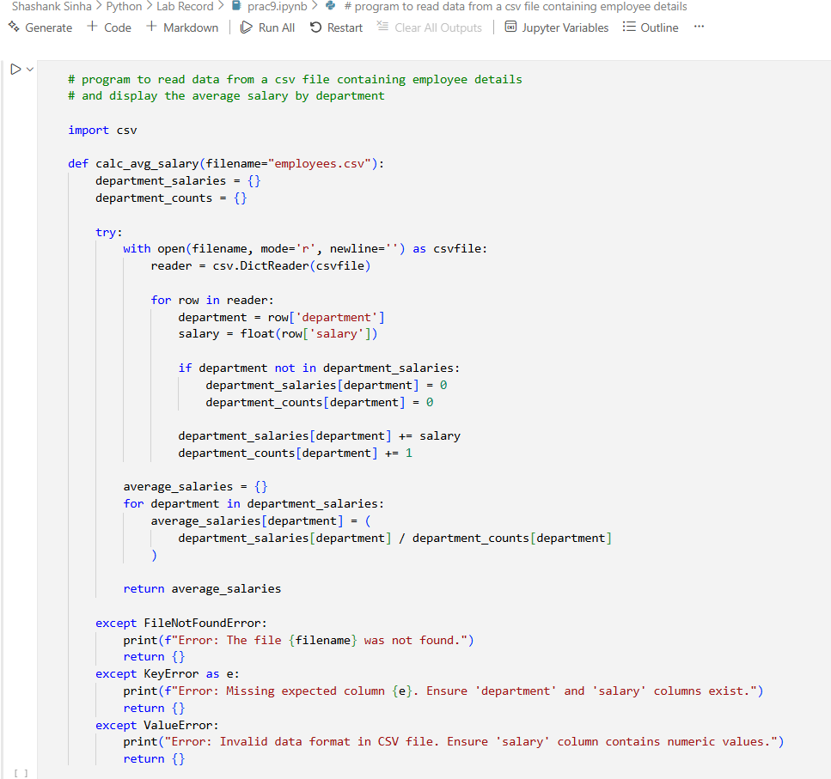

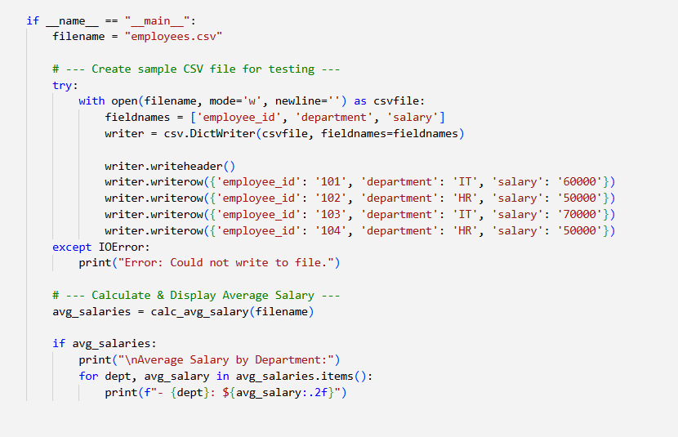

Output :-
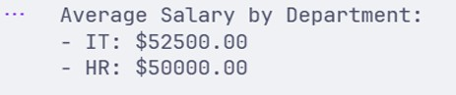

Practical-10
Aim:- Write a python program using math module to calculate:
a) square root of a number
b) factorial of a number
c) power of a number
(take input from the user)

Code:-
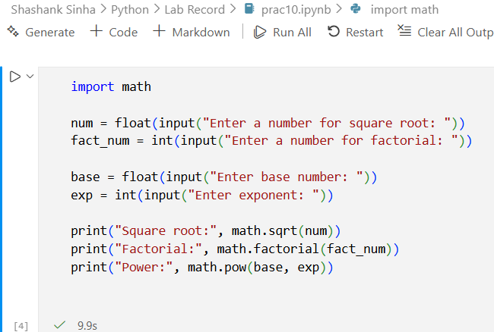

Input:-
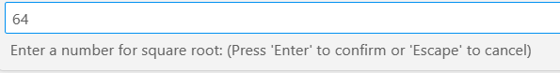
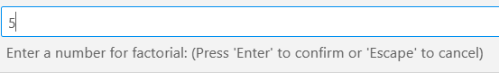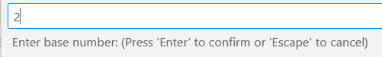
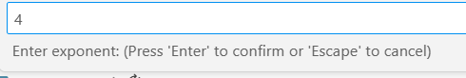

Output:-
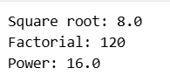

Practical-11
Aim:- Write a python program to find the area and circumference of a circle using math module, take input from the user
Code:-
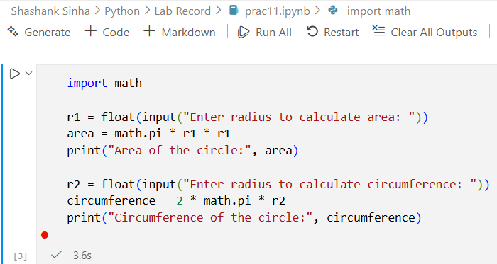

Input:-
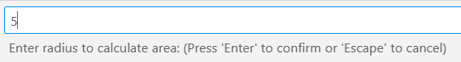
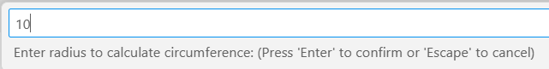

Output:-
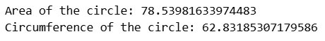

Practical-12
Aim:- Create a list of student and select CR randomly, then shuffle the list and print it.

Code:-
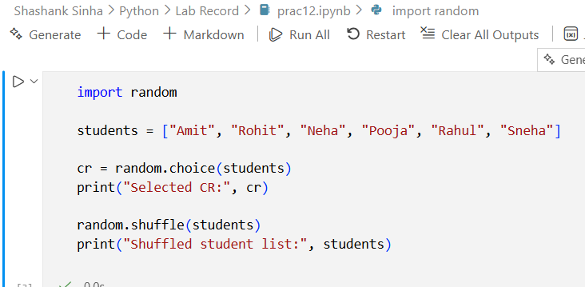

Output:-
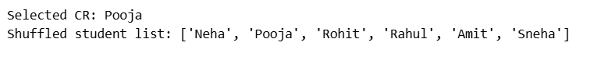

Practical-13
Aim:- Write a python program to generate a random password of 12 characters using UPPERCASE, lowercase, digits and special symbols(!, @, #, $, *). Password should start with Capital letter or digits.

Code:-
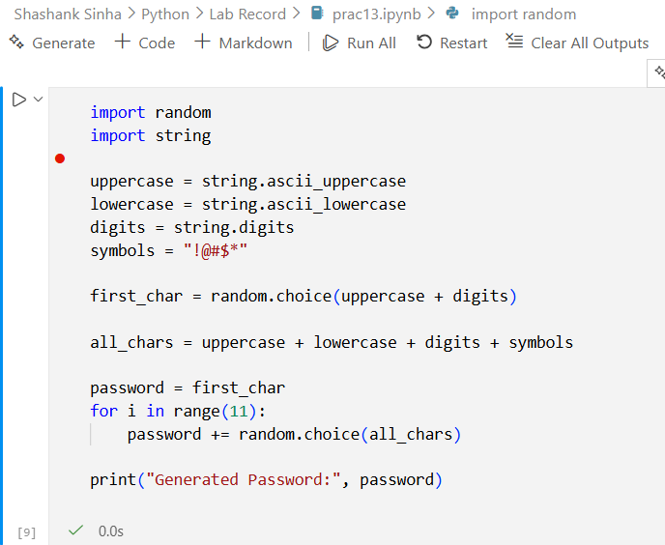

Output:-
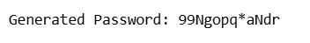

Practical-14
Aim:- Create a package named shapes that contains two modules: circle.py and rectangle.py. Each module should compute area and perimeter of the shape. Write the complete directory structure and sample code.
Module 1(circle.py)
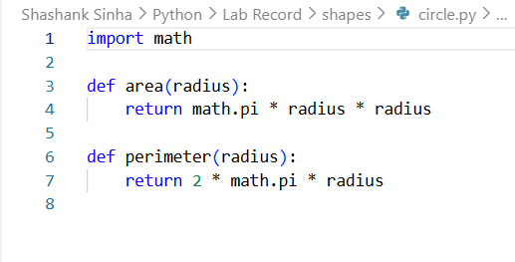
Module 2(rectangle.py)
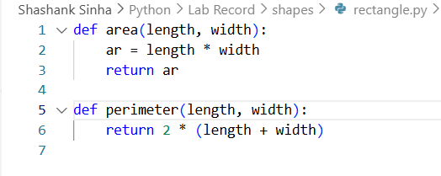
Directory Sample
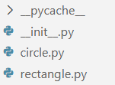

Code:-
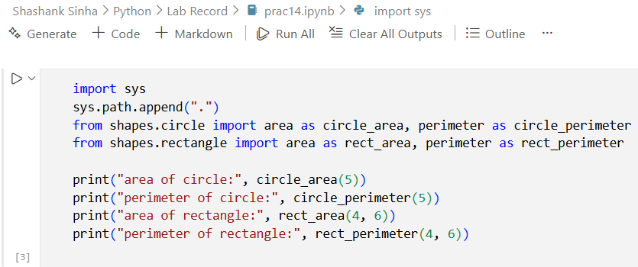

Output:-
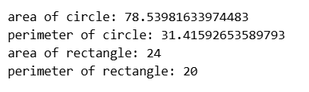

Practical-15
Aim:- Write a program that asks the user for an index and prints the element at that index from a predefined list.
Handle:
- IndexError (index out of range)
- TypeError (if user enters a non-integer index)
- Print the specific exception message using except Exception as e.

Code:-
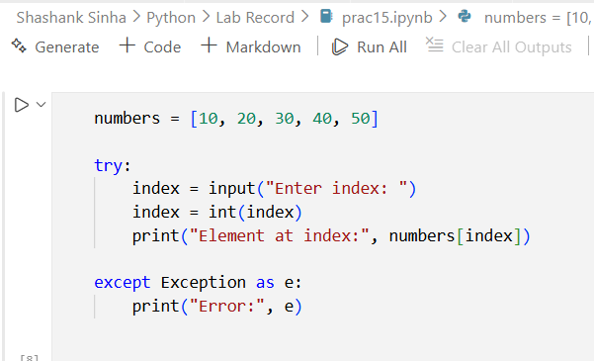

Output:-
1
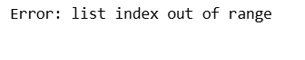
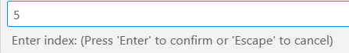
2
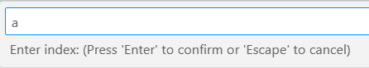
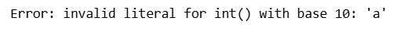
3
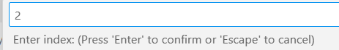
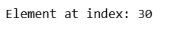

Practical-16
Aim:- Implement a supervised learning model to classify flowers in the Iris dataset using Decision Tree Classifier. Print the accuracy of the model.
Code:-
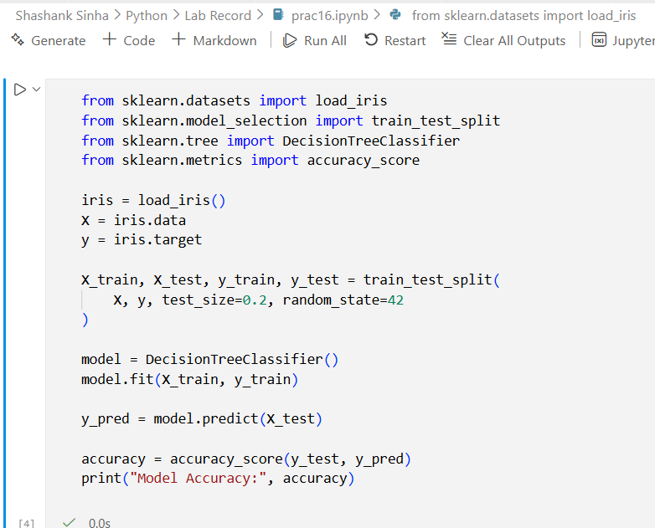

Output:-
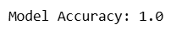

Practical-17
Aim:- Use Support Vector Machine (SVM) on the Breast Cancer datasets to classify malignant vs benign tumors.

Code:-
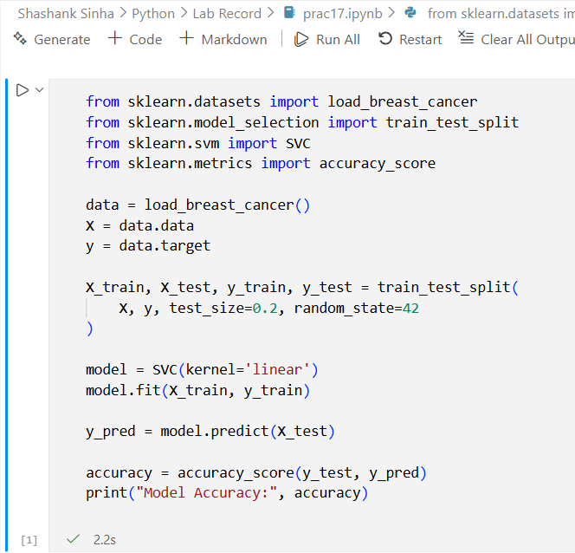

Output:-
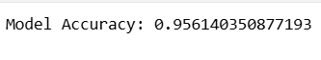
Practical-18
Aim:- Perform Principal Component Analysis (PCA)on the Digits dataset and reduce the dimension to 2. Print the explained variance ratio.

Code:-
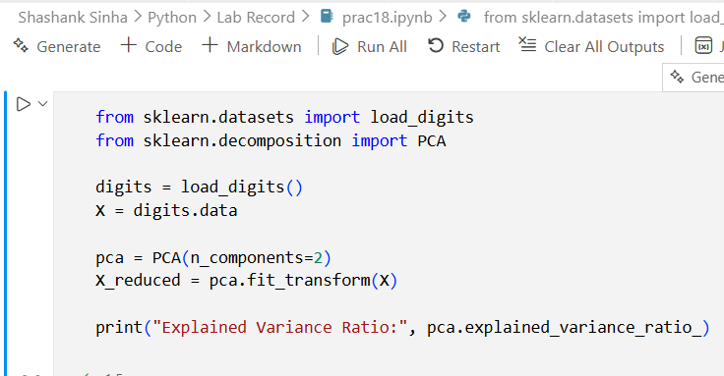

Output:-
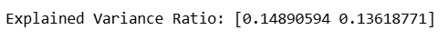

Practical-19
Aim:- Apply K-Means clustering on the Iris Dataset and print cluster labels.

Code:-
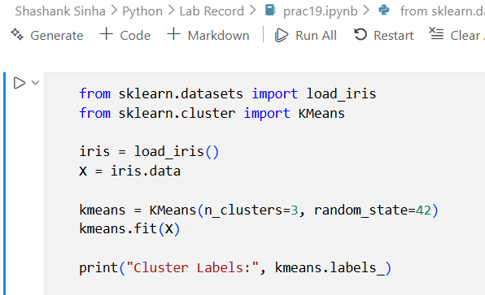

Output:-
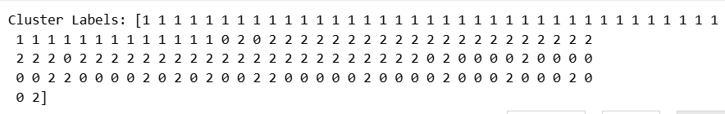

Practical-20
- Aim:- Write a Python program to perform basic EDA on a student performance dataset to understand its structure and summary statistics. (dataset attached along with filename – sample_dataset)
- Load the dataset into Python
- Display the first five records
- Display the shape of the dataset
- Show column names and data types
- Check for missing values
- Display basic statistical summary

Code:-
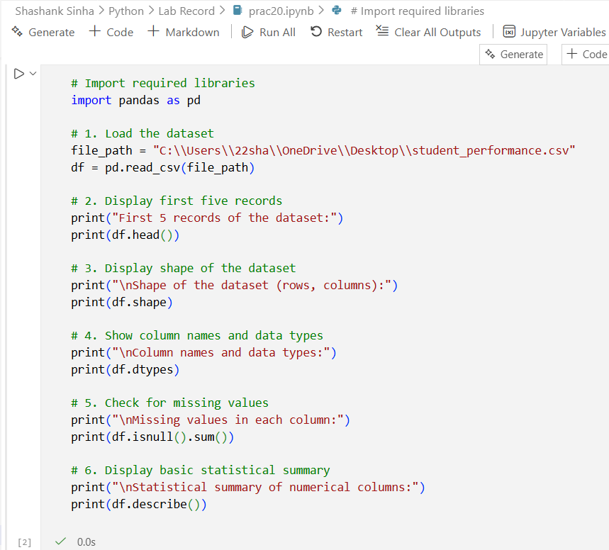

Output:-
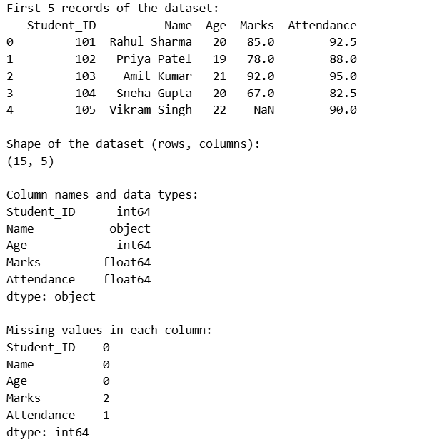
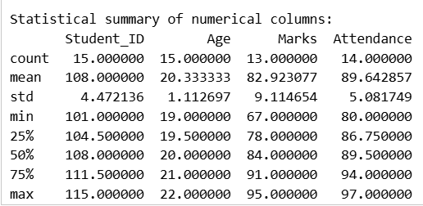
Practical-21
Aim:- Write a Python program using pandas to analyze a sales dataset and extract meaningful insights.
- Load the dataset into a pandas DataFrame
- Create a new column Total_Revenue by multiplying Units_Sold and Price_Per_Unit
- Find the total revenue generated for each product
- Find the total units sold for each category
- Calculate the average price per unit for each category
- Find the product with maximum units sold
- Group the data by Month and calculate the total revenue for each month
- Filter and display products where Units_Sold is greater than 40
- Sort the dataset by Total_Revenue in descending order

Code:-
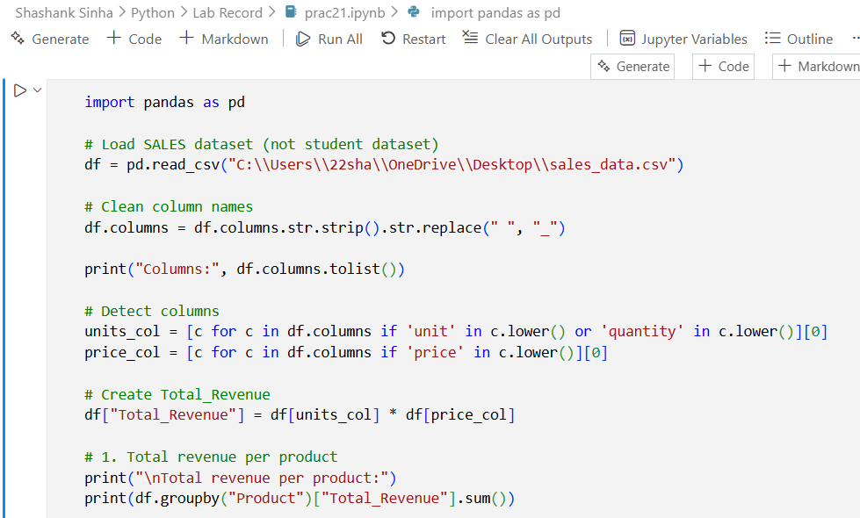
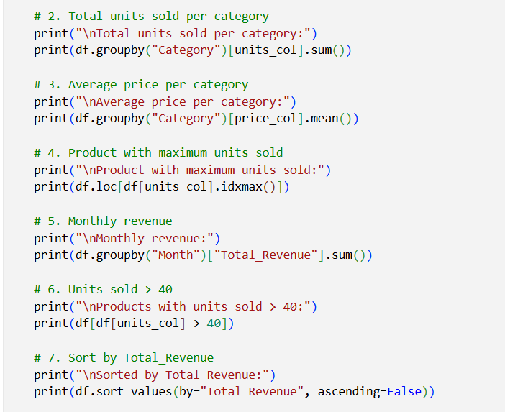

Output:-
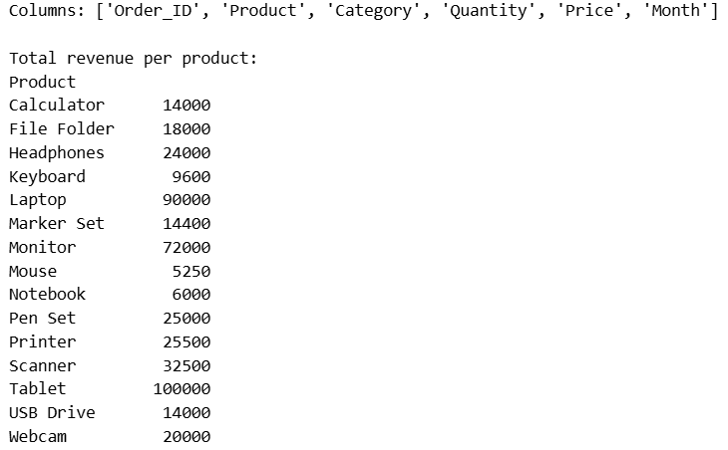

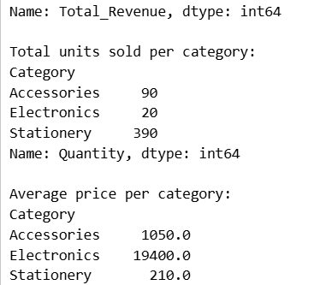
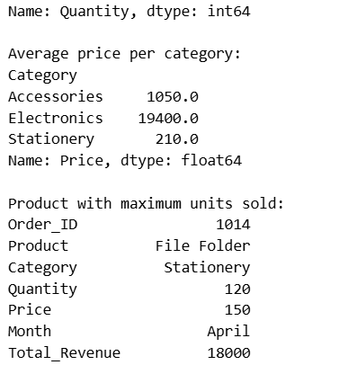
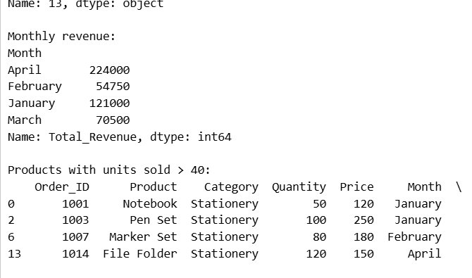
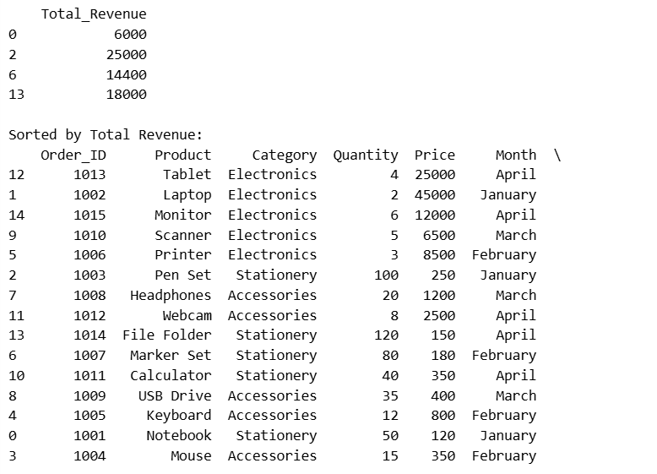
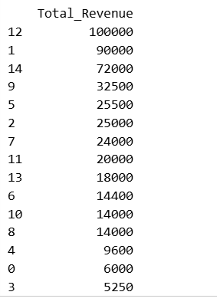

Practical-22
Aim:- Write a Python program to visualize an employee dataset using matplotlib and seaborn to understand data distribution and relationships.
- Plot a histogram for Salary
- Draw a box plot for Age
- Create a bar chart showing department-wise employee count
- Plot a scatter plot between Experience and Salary
- Display a correlation heatmap

Code:-
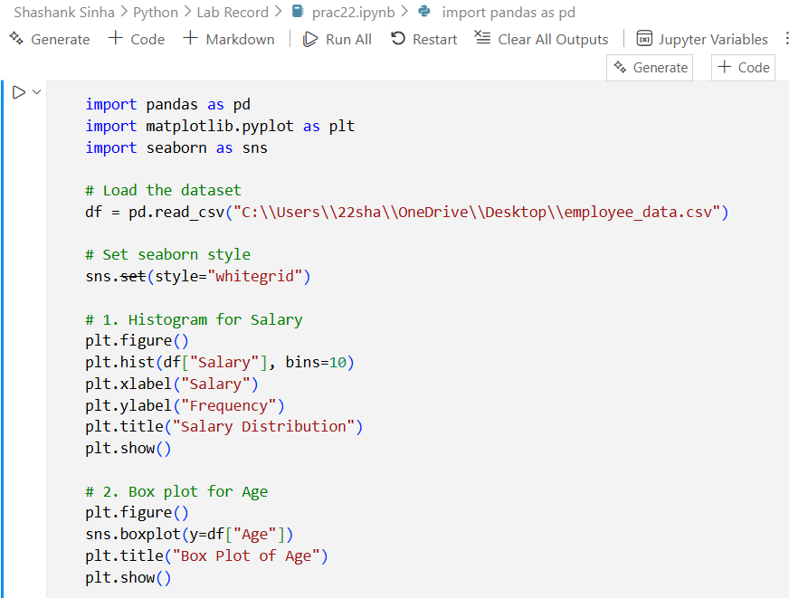

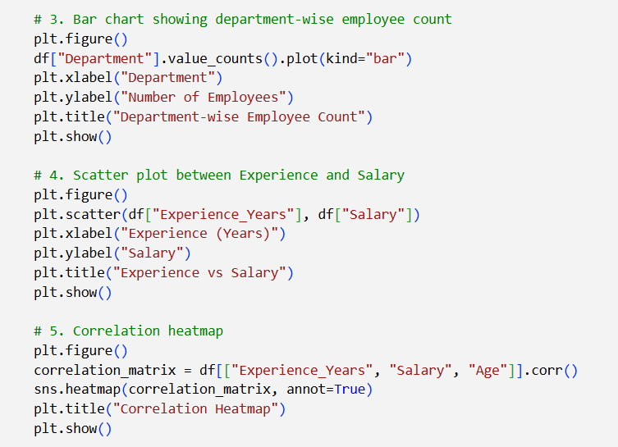

Output:-
